**TASK -11**

**Q1.Output screenshot :**

**\***Navigate to the URL **https://the-internet.herokuapp.com/windows**

*Newly Opened Window

**\***Original Window is Active

**\***Output print in the Console

**Q2.Output Screenshot :**

**\***Navigate to the URL : http://the-internet.herokuapp.com/nested_frames

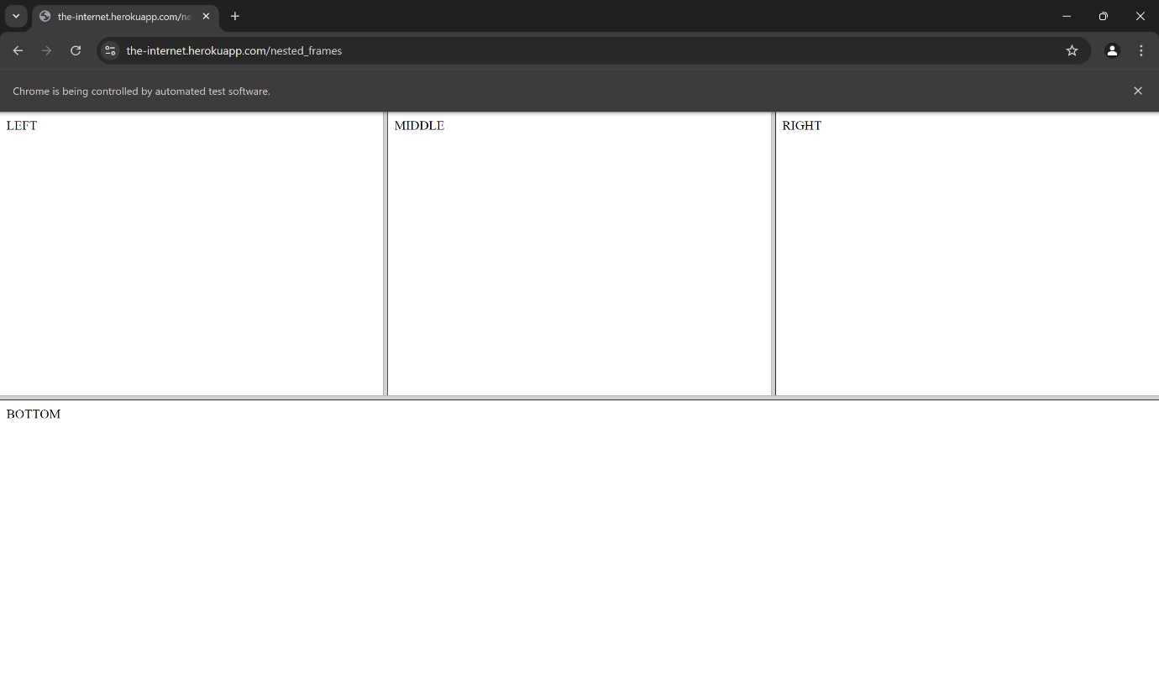

*Output print in the console

